* Start with Sahi Web Automation - Basic Understanding
* Start with Sahi Web Automation - Developed Automation Framework.

|  |  |
| --- | --- |
| **Prepared By:** | Abhijeet Thalkari |
| **Started On:** | 1st June 2013. |
| **Updated By:** | Abhijeet Thalkari |
| **Updated On** | 1st July 2013. |

* **Start with Sahi Web Automation - Basic Understanding** (**Considering you all know basics of Sahi Tools.**)

1. Sahi is Web Automation Tool in which two kinds of tools available for use

* **Sahi OS:** It’s an open source tool.
* **Sahi Pro:** It’s a paid tool worth of $495/year.

1. In Sahi OS also most of the functionalities we can develop which is covered in Sahi Pro.
2. Start with **Sahi Open Source.**
3. Download latest version of Sahi OS. Also download latest version of **JDK 32 bit**.
4. Remember 32 bit of JDK supports ODBC connection so you need to install 32 bit JDK.
5. After Installing JDK set **“JAVA_HOME”** environment variable and set value in **“path”** variable also.

* **JAVA_HOME=** C:\Program Files\Java\jdk1.7.0
* **Path=**C:\Program Files\Java\jdk1.7.0\bin

1. Now install Sahi on **“D”** drive.
2. After Installing you will get folder of sahi on **“D”** drive.
3. Now you are ready to start with sahi.
4. Click on Sahi shortcut created on desktop.



1. By default, all browsers installed on your PC are shown. If not then click on Configure link

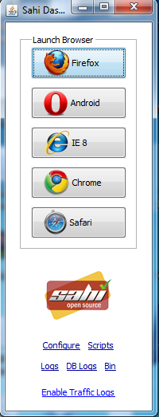

1. Go to browser_types.xml, you will see that there is some configuration for browsers. Check whether path for installed directory of browsers is mentioned properly or not. If not, change the path and restart the sahi.
2. To check Sahi is working on all browsers taking example of one browser i.e. Mozilla

* Start Sahi
* Click on Mozilla browser you will get following screen.

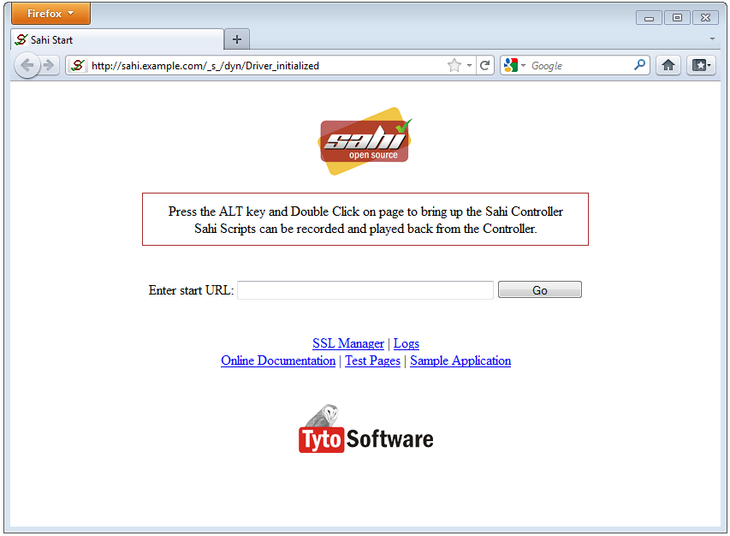

* **ALT + Double Click** to open sahi controller you will get controller as shown below
* Now to identify object just press **“Ctrl”** key and over the mouse on any object you will get all the details of the objects in Accessor and Alternatives.
* For checking that sahi is working or not; press **Ctrl** and hover the mouse on textbox of name **“Enter start URL:”** and enter value as **“Test”** in **“Value:”** textbox of controller.
* Click on **Set** button on controller. You will see that Test is entered in textbox as shown in figure. If Test is entered then Sahi is working properly.
* Else you can check:
* Firefox: <http://sahi.co.in/forums/discussion/4779/firefox-20-0-giving-issues-to-anyone/p1>
* Chrome (If controller not opening for Chrome browser): <http://sahi.co.in/forums/discussion/4624/sahi-controller-doesnt-open-with-chrome-version-24-0-1312-52-m/p1>
* Or just search on Google with your problem. I am sure; you will get many solutions from Sahi forums and Sahi blogs.

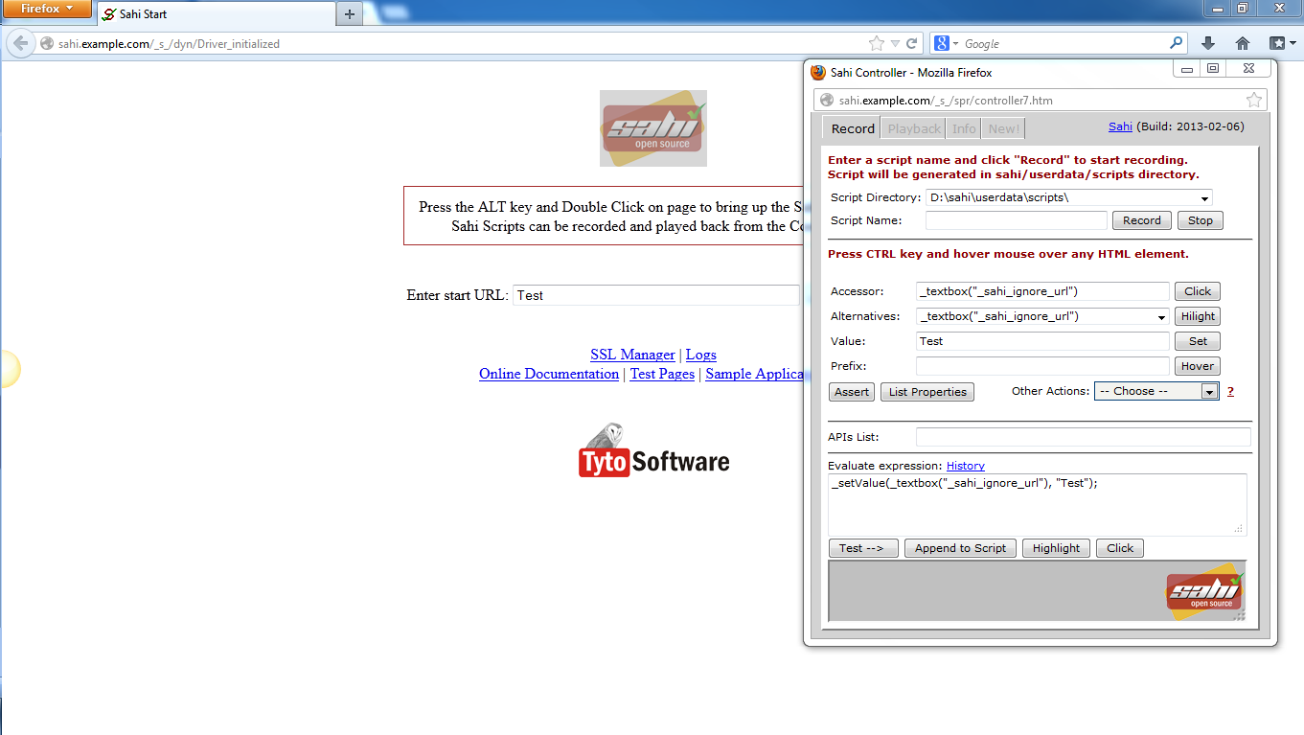

1. As described above; check all browsers are working and controller is opening for each browser.
2. Now you are ready to start with Sahi Web Automation Tool and Sahi Scripting.
3. Before starting; Please go through <http://sahi.co.in/w/using-sahi> for better understanding of Sahi Web Automation Tool.
4. Some sample format of how to write script please refer below scripts(Generalized)

* **Action**= name of operation you want to perform on objects.
* **Object type**= name of object type e.g. “textbox”,”button”,”link” etc
* **Object name**= name of object
* **Value**= Value if any.
* **Position**=near or under position( This is basically used when you are performing action on particular object with reference to another object)
* **Nearobjecttype**: Type of reference object
* **Nearobjcetname**= Name of reference object
* **Underobjcettype**- Type of reference object
* **Underobjcetname**- Name of reference object

1. Please refer some generalize script which is helpful to understand “How to write a script?”

* _action(_objecttype(“object name”),”value”);
* _action(_objecttype(“object name”));
* _action(_objecttype(position,_near(_nearobjcettype(“nearobjectname”))),”value”);
* _action(_objecttype(position,_near(_nearobjcettype(“nearobjectname”))));
* _action(_objecttype(position,_under(_underobjcettype(“underobjcetname”))),”value”);
* _action(_objecttype(position,_under(_underobjcettype(“underobjcetname”))));
* _action(_objecttype(position,_near(_nearobjcettype(“nearobjcetname”)),_under(_underobjecttype(“underobjectname”))),”value”);
* _action(_objecttype(position,_near(_nearobjcettype(“nearobjcetname”)),_under(_underobjecttype(“underobjectname”))));

1. With the above script; you can check “How actual script is written?”

* _setValue(_textbox(“Login”),”Abhijeet”);
* _click(_button(“Submit”));
* _setSelected(_select(0,_near(_label(“Country”))),”India”);
* _check(_checkbox(0,_near(_label(“Male”))));
* _setValue(_password(0,_under(_span(“Please Login”))).”abcd1234”);
* _click(_radio(0,_under(_label(“Male”))));
* _setValue(_textarea(0,_near(_cell(“Samsung”)),_under(_cell(“Prize”))),”250”);
* _click(_submit(0,_near(_div(“Samsung”)),_under(_cell(“Prize”))));

1. Hope this will helpful for you to understand how script is written.

* **Start with Sahi Web Automation - Developed Automation Framework.**

1. Extract TAF_SAHI folder in **D:\sahi\userdata\scripts**
2. Functionalities Provided By this automation framework

* You can write your **Scenarios** and **Test cases** script here.
* Step by step script writing with proper **keywords**.
* Provided with the **action/operation** dropdown; which is useful in automation.

E.g. click, setValue, check etc.

* Match Type as **TRUE** and **FALSE** for checking whether button is enabled or not also to check radio /checkbox are selected or not. (Verification)
* Provided most of the **Object** types e.g. textbox, button, checkbox, select (combo box) etc
* Provided with **Near** concepts and **Under** concepts. (You can perform operation on object with reference to the other object.)
* **Data Value**- Your Input (DATA)
* Also provides some keywords for random data generation in Data Value column of your choice of length.(Length should be mentioned in **Near_ObjectPosition** column**)**
* **randomstringemail**
* **randomstring**(Alphanumeric string)
* **randomstringchar**(string having only characters)
* **randomstringnum**(string having only numbers)
* Also have a provision to use the random data generated using above keywords for further verification in Data Value and Object Name column( You can use the random data till you will not create another new random data of respective type)
* **previousstringemail**
* **previousstring**
* **previousstringchar**
* **previousstringnum**
* Provision of Execution Flag: Just give Yes or No in **ExecutionFlag** column
* Just give **Yes** or **No** at the start of the Test case means in the First step of your test case or scenario under **ExecutionFlag** column.
* Screenshot for each and every steps
* Screenshot captured for every step and creates one folder of name TestCaseId and store captured screenshot of every step in respective folders.
* Screenshot of Failure Steps.
* Report Generation
* Step Wise Report Generation(Default Report)
* Test case wise report generation (This report will get after clicking on button **“Generate Test Case Wise Result”**
* Execution Round Wise Report generation (This report will get after clicking on Generate **“Test Cases Round Wise Report”**
* Charts
* Test Case Wise Pie Chart
* Test Case Wise Column Chart
* Test Case Round Wise Column chart.
* Alert Handling.
* File Upload and Download.
* Custom Function Generation whenever necessary.
* Multiple Test Data Files Execution: Provided **Test_Case_Files_Inventory** file where you can give the paths of the excel files which you want to execute.
* Precondition Sheet: Just write steps and define your preconditions in this sheet and call this precondition whenever necessary.

1. Almost everything is provided in Excel framework; only you need to have object type and object name and start with excel framework with provided operations/actions in it. e.g.

* For Writing Automation Framework just refer **Test_Data_File**(Micro Enabled File.)

**D:\sahi\userdata\scripts\TAF_SAHI\Test_Case_Test_Data_Files\Test_Data_Fil.xlsm**

*Hope, this Document will help to start with Automation Framework using Sahi.*

*For any further information about Framework please feel free to contact me. ☺*

***All the Best.***